Re-AIM
Re-AIM: A Multi-Client Chat System with Rooms and Private Messaging
Project Summary
Re-AIM (Real-Time Application for Instant Messaging) is a Java-based multi-client chat application that allows multiple users to connect to a central server and communicate in real time using TCP/IP sockers. Each user connects through a client program and exchanges messages with other users via the server.
The System will support multiple chat rooms and private messaging. Users will be able to join or leave rooms dynamically and send direct messages to others using command-based inputs. The server will manage connections, track users, and rout messages appropriately.
Concurrency will be implemented using multi-threading, where each client connection is handled independently using a dedicated thread. This allows multiple users to interact with the system simultaneously without blocking. Shared resources such as users lists and chat rooms will be synchronized to prevent race conditions and ensure consistency.
The system will also emphasize robustness through error handling. The server will gracefully handle invalid input, unexpected client disconnections, and I/O erros without crashing, ensuring a stable mult-user experience.

How This Meets the Core Requirements
Network Communication:
Re-AIM uses Java’s ServerSocket and Socket classes to establish TCP/IP connections. Clients and the server communicate using input and output streams to exchange messages.

Concurrency:
Each client is handled by a separate thread using the ClientHandler class, allowing multiple clients to interact with the server at the same time.
Shared State Management:
The server maintains shared data structures such as a list of active users and chat rooms. These structures are synchronizied to prevent race conditions.
Resilience and Error Handling:
The system catches I/O Exceptions and handles invalid inputs. If a client disconnects unexpectedly, the server removes the user and continues running without interruption.

Specific Deliverables
- Implement a command-based messaging system where users can execute commands such as /join roomName, /leave, /dm username message, and /list
- Develop a room-based messaging system where users can only receive messages from the chat room they have joined, with the ability to dynamically switch between rooms
- Create a user session management system that enforces unique usernames, tracks active users, and automatically removes users from the system upon unexpected disconnection

Flowchart 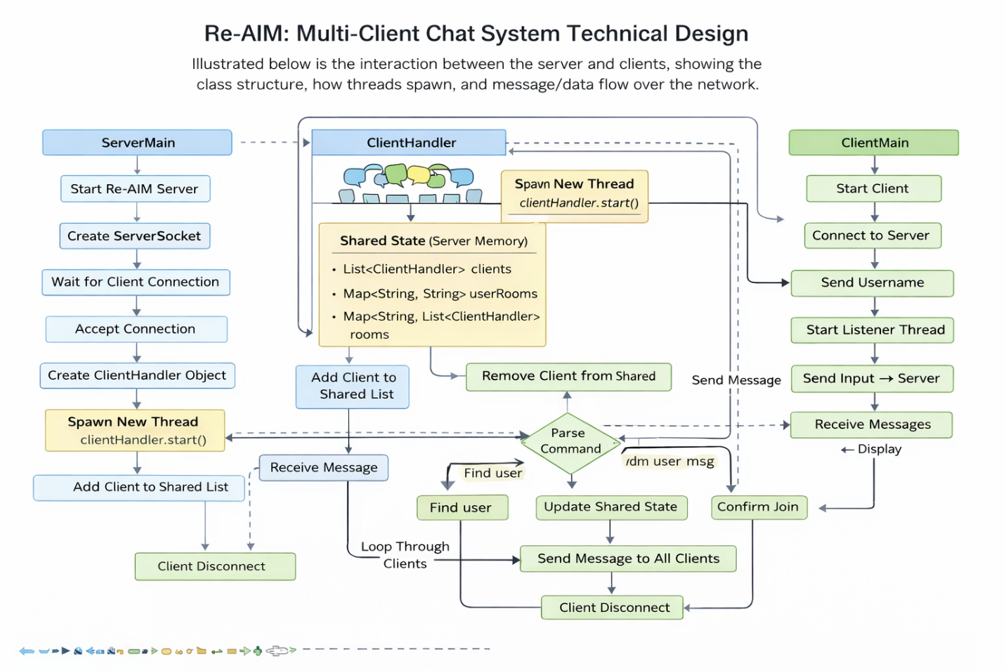

The diagram shows how the client and server interact in Re-AIM. The server listens to connections and spawns a new thread for each client using a ClientHandler. All clients are stored in a shared data structure, which allows the server to manage users and route messages. When a client sends a message, the server parses it and determines whether to broadcast it, send it privately, or update room membership. The system also handles client disconnections gracefully by removing them from shared state.

Initial Skeleton Code

ServerMain.java
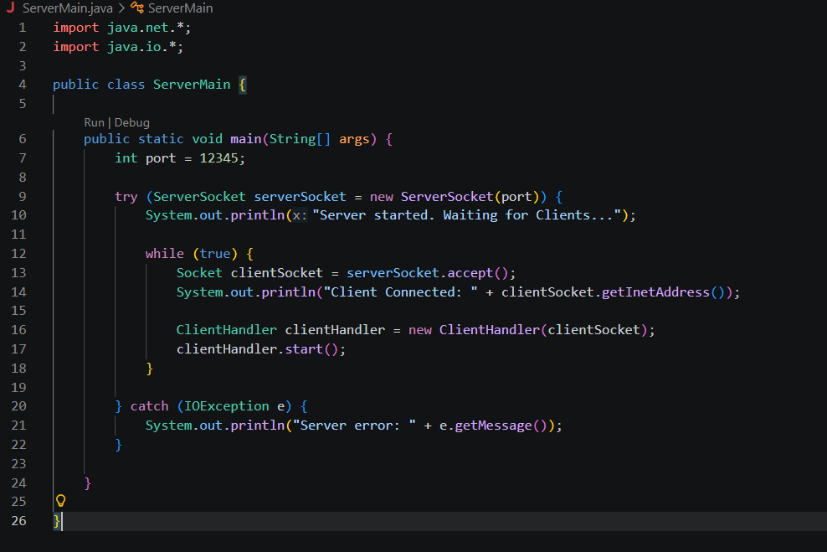

ClientHandler.java
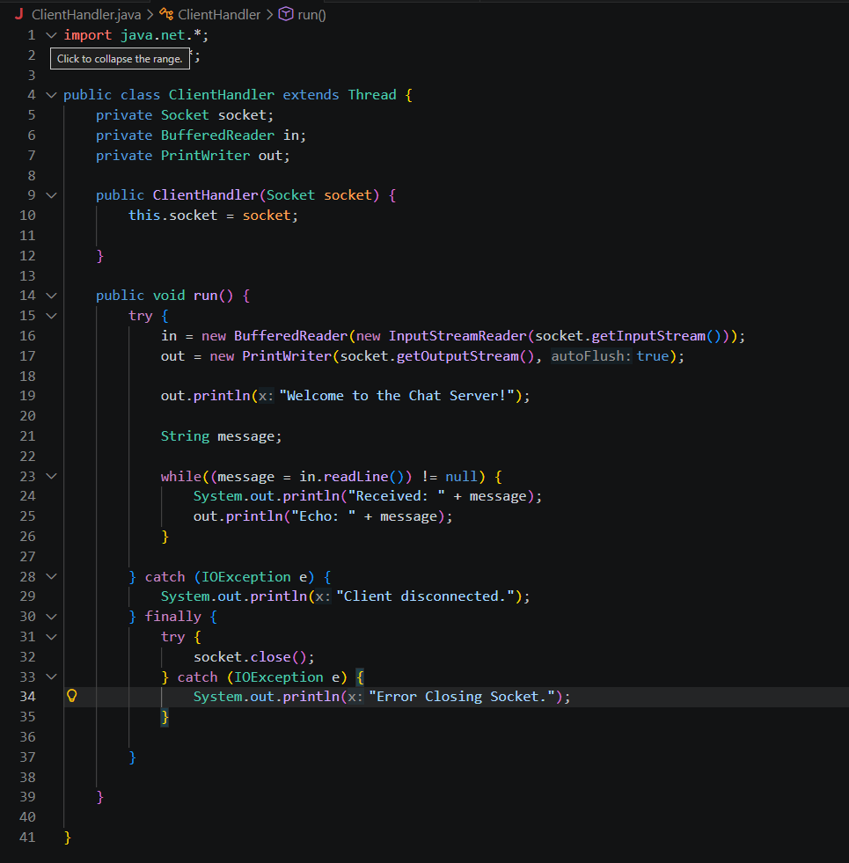

ClientMain.java
